 | Transport and Communications Science Journal | 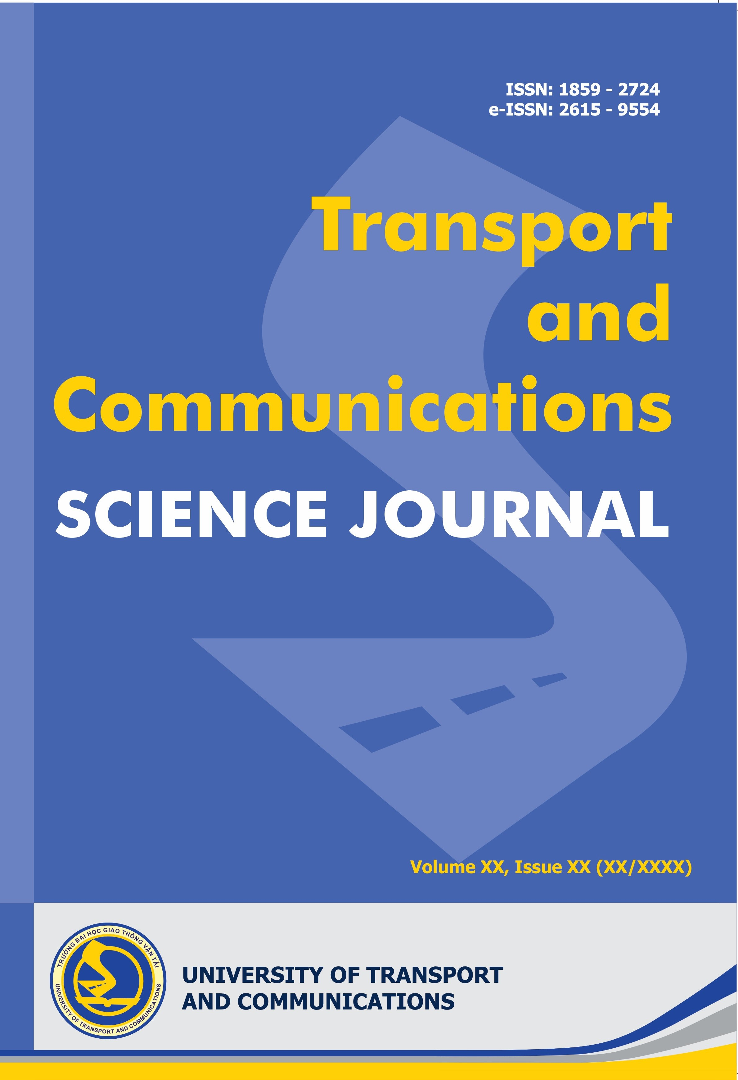
DAMAGE DETECTION IN A STEEL BEAM STRUCTURE USING A SOFT SENSOR AND LOGISTIC REGRESSION
Nguyen Thanh Nguyen^{1,2}, Le Ngoc Bin², Cedric Sauzeat³, Dang Van Tien^{1*}
¹University of Transport and Communications, No 3 Cau Giay Street, Hanoi, Vietnam
²Posts and Telecommunications Institute of Technology, No 122 Hoang Quoc Viet Street, Hanoi, Vietnam
³LTDS (UMR CNRS 5513), University of Lyon/ENTPE, Vaulx-en-Velin, France

ARTICLE INFO
TYPE: Research Article/ Scientific communication (select one by author)
Received: … (edited by editors)
Revised: … (edited by editors)
Accepted: … (edited by editors)
Published online: … (edited by editors)
https://doi.org/10.1080/14680629.2017.1389072 (edited by editors)
* Corresponding author
Email: nguyenvanA@utc.edu.vn; Tel: 0912345678 (optional)
Abstract. One or two sentences providing a basic introduction to the general field, understandable to any reader. One or two sentences clearly stating the problem being solved by this study. Experimental methods/simulation methods should be presented in several sentences. The main result should be summarised in one or two sentences. Finally, one or two sentences is to provide the meaning of study presented in this article. The length of the abstract paragraph should be limited from 150 to 250 words. The abstract does not contain equations, tables, or references. The abstract is to be in 12pt, Times New Roman, single-space type. The manuscript submission would be done at the tcsj online ssystem http://tcsj.utc.edu.vn/index.php/tcgtvt/about/submissions

Keywords: reinforced concrete, cable-stayed bridge, electronic circuit, image recognition, transportation (listing up to 6 words or phrases in lower case, separated by commas).
@ 2024 University of Transport and Communications

1. INTRODUCTION
Please follow the steps outlined below when submitting your manuscript to TCSJ [1-4]. The manuscript must respect to the TCSJ’s format, the authors can use: Copy/Paste Special/Unformatted text to copy text to corresponding locations [5]. The article is written on A4 paper (210 mm x 297 mm), 12 pt, Times New Roman (Unicode); upper alignment: 3.0 cm; bottom: 3.3 cm, left: 2.55 cm, right: 2.55 cm. This instruction has been formatted based on request of the Journal Editorial Board, the author can replace the content of the article in all sections without changing the format of the article (font, font size, row spacing, left alignment, right margin) [6-8]. No page numbering. The minimum number of references is 10 together with DOI link. The TCSJ strongly recommend the authors cite the articles indexed at the systems of web of science, Scopus

Headings
FIRST-ORDER HEADINGS. (For example, 1. INTRODUCTION) should be 12pt, Times New Roman, boldface, capitalized, left alignment, with one blank line before, and one blank line after.
Second-order headings. (For example, 1.4. Languages) should be 12pt, Times New Roman, boldface, initially capitalized, left alignment, 6pt spacing Before and After. If you require a third-order heading, use 12pt Times New Roman, boldface, initially capitalized, 6pt spacing Before and After, followed by a space and your text on the same line [9-10].

Title of manuscript
Title of manuscript should be in 15pt, Times New Roman, boldface capitalized, and center alignment. If there are several authors, name of the main author would be placed first. Affiliation of all authors and the corresponding author’s email are provided to contact with the Editorial Board and readers.

Paper length
The paper length is limited to be 15 pages (typical 10 pages, includes tables, figures, references, and appendix).

Languages
Manuscript is written in English.

Dual submission
When submitting a manuscript to TCSJ, the authors ensure that it has not been previously published or accepted for publication in any other journals, the main results must not overlap with previous researches. If the manuscript violates any of the above rules, it will be rejected. While waiting for the review results, the authors are not allowed to submit research results or part of the results to other conferences, seminars, or journals [11-18].

2. EQUATION GUIDE

Equation style
Using MathType (http://www.mathtype.com) or Microsoft Equation to express an equation in the manuscript. Equations must be numbered sequentially from the beginning to the end of the manuscript, the order of the equation is placed in parentheses to the right of the page. For example:
$\frac{e^{\text{ix}}}{2}=\frac{\text{cos}x+i\text{sin}x}{2} ⇒ \text{exp}(\text{ix})/2=(\text{cos}x+i\text{sin}x)/2$ (1)
In the equations, text must be in italic; matrix and vector symbols are in bold, italic; others are normal. It is worth to note that, all symbols in the equation must be pre-defined or immediately defined after the equation. In writing, the equation should be referred as “eq. (1)” or “Eq. (1)” at the beginning of a sentence.

Equation typing

$f=(\text{cos}x+i\text{sin}x)/2$ (2)

3. FIGURES AND TABLES

Figures and tables
Figures have to created by author/authors. Authors have to get an approval of reutilization of any figure from any source and have to clearly state/cite in main text.
Figures and tables should be placed at the top or bottom of the page. The caption of a figure is placed under the figure and the caption of the table is placed above the table, all caption is centered alignment (illustrated as below). Images can in colors, however, must be ensured in clear conditions when printing. When referencing, it is necessary to specify the figure, for example: ... as shown in Fig. 1, or at the beginning of a sentence, "Fig. 1 shows that ...". The images should be in vector format, using "Paste Special/Enhanced Metalfile” function to get good image quality. The resolution of the image should be more than 300 dpi.

Figure 1. Surveillance (Times New Roman, 11pt).
Table 1. Ultimate load of sandwich specimens.
Set | Panel | Textile reinforcement |  |  | Load (kN) |  |  | Failure mode
Set | Panel | Nº  layers | Total area (mm²) | Ratio (%) | Crack-ing | Load at failure | Ultim  -ate | Failure mode
Set 1: SWA | SWA1-1 | 1 | 4.67 | 0.016 | 18.30 | 7.58 | 18.30 | Tensile break of textile/ Flexure failure
Set 1: SWA | SWA1-2 | 1 | 4.67 | 0.016 | 17.84 | 7.15 | 17.84 | Tensile break of textile/ Flexure failure
Set 1: SWA | SWA2-1 | 2 | 9.33 | 0.033 | 19.70 | 1.98 | 19.70 | Tensile break of textile/ Flexure failure
Set 1: SWA | SWA2-2 | 2 | 9.33 | 0.033 | 18.77 | 14.22 | 18.77 | Tensile break of textile/ Flexure failure
Set 1: SWA | SWA3-1 | 3 | 14 | 0.049 | 19.65 | 19.03 | 19.65 | Tensile break of textile/ Flexure failure
Set 1: SWA | SWA3-2 | 3 | 14 | 0.049 | 18.13 | 18.95 | 18.95 | Tensile break of textile/ Flexure failure
Set 1: SWA | SWA4-1 | 4 | 18.67 | 0.065 | 19.45 | 26.33 | 26.33 | Diagonal cracks/ Shear failure
Set 1: SWA | SWA4-2 | 4 | 18.67 | 0.065 | 18.44 | 26.22 | 26.22 | Diagonal cracks/ Shear failure
Set 1: SWA | SWA5-1 | 5 | 23.35 | 0.08 | 19.54 | 31.21 | 31.21 | Diagonal cracks/ Shear failure
Set 1: SWA | SWA5-2 | 5 | 23.35 | 0.08 | 18.69 | 27.48 | 27.48 | Diagonal cracks/ Shear failure
Set 2:  SWB | SWB1-1 | 1 | 19.8 | 0.068 | 19.84 | 26.02 | 26.02 | Diagonal cracks/ Shear failure
Set 2:  SWB | SWB1-2 | 1 | 19.8 | 0.068 | 18.25 | 25.68 | 25.68 | Diagonal cracks/ Shear failure
Set 2:  SWB | SWB2-1 | 2 | 39.6 | 0.137 | 18.69 | 27.38 | 27.38 | Diagonal cracks/ Shear failure
Set 2:  SWB | SWB2-2 | 2 | 39.6 | 0.137 | 21.48 | 30.79 | 30.79 | Diagonal cracks/ Shear failure
Set 3:  SWC | SWC1-1 | 1 | 20 | 0.069 | 16.92 | 20.47 | 20.47 | Textiles break / Flexure failure
Set 3:  SWC | SWC1-2 | 1 | 20 | 0.069 | 17.82 | 22.52 | 22.52 | Textiles break / Flexure failure
Set 3:  SWC | SWC2-1 | 2 | 40 | 0.138 | 21.83 | 28.01 | 28.01 | Diagonal cracks/ Shear failure
Set 3:  SWC | SWC2-2 | 2 | 40 | 0.138 | 20.23 | 30.07 | 30.07 | Diagonal cracks/ Shear failure

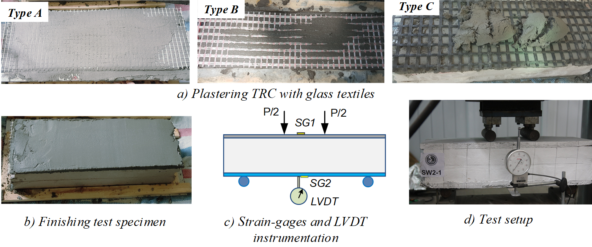
Figure 2. Fabricating specimens and test setup.

Table 2. Latitude and longitude of some big cities (Times New Roman, 11pt).
 | Tokyo | New York | Paris | Singapore
Latitude | 35.69 | 40.78 | 48.73 | 1.37
Longitude | 35.69 | 40.78 | 48.73 | 1.37
Temperature | 35.69 | 40.78 | 48.73 | 1.37
Velocity | 35.69 | 40.78 | 48.73 | 1.37
UV degree | 35.69 | 40.78 | 48.73 | 1.37
Humidity | 35.69 | 40.78 | 48.73 | 1.37

Figure 3. (a) IoT device. (b) Photos of device implementation on the bridge (Times New Roman, 11pt).
Figure 4. CMC curves in different cases (Times New Roman, 11pt).

Citing references
Text: Indicate references by number(s) in square brackets in line with the text. The actual authors can be referred to, but the reference number(s) must always be given. In order to cite a research which has many authors, it is possible to use "et al.". However, this character set is only used when the research has at least three authors. When referencing many researches, it is necessary to keep the reference order, for example: [11,12,13], '... as demonstrated [13,16]. Barnaby and Jones [18] obtained a different result ...'.
The minimum number of references is 10.
List: Number the references (numbers in square brackets) in the list in the orders in which they appear in the text. In References section, authors of the manuscript must be fully listed; do not use “et al.”. References should be quality researches and within 5 years.
For examples:
- Reference to a journal publication [1]
- Reference to a journal publication with an article number [2]
- Reference to a book [3]
- Reference to a chapter in an edited book [4]
- Reference to a website [5]
- Reference to a dataset [6]
- Reference to a conference paper [7]
- Reference to a Patent [8]
- Reference to a Graduation dissertation [9]

4. CONCLUSION
When the manuscript is received, the Editorial Board will preliminary check the content and presentation, if the manuscript has enough scientific content, there is no duplication and response the requirements in terms of form, we will send the manuscript to the reviewers. After reviewing, if there is any a request to revise, the authors must edit the manuscript and send it to the Editorial Board before the deadline specified previously. The deadline is specifically notified via email to the corresponding author.

ACKNOWLEDGMENT
Thanks to the organizations for their contribution to the research. For example:
This research is funded by University of Transport and Communications (UTC) under grant number T20xx. This research is partly funded by Vietnam National Foundation for Science and Technology Development (NAFOSTED) under grant number 102.01-2017.12. Authors would like to thank Prof. Jond Nam, University of Hardvard for his helpful discussion.
REFERENCES
- J. Van der Geer, J. A. Hanraads, The art of writing a scientific article, J. Sci. Commun, 163 (2010) 51-59. https://doi.org/10.1016/j.Sc.2010.00372
- J. Van der Geer, J. A. Hanraads, The art of writing a scientific article, Heliyon, 19, e00205, 2018. https://doi.org/10.1016/j.heliyon.2018.e00205
- W. Strunk Jr., E. B. White, The Elements of Style, fourth ed., Longman, New York, 2000.
- G. R. Mettam, L. B. Adams, How to prepare an electronic version of your article, in: B.S. Jones, R.Z. Smith (Eds.), Introduction to the Electronic Age, E-Publishing Inc., New York, 2009, pp. 281-304.
- Cancer Research UK, Cancer statistics reports for the UK. http://www.cancerresearchuk.org/aboutcancer/statistics/cancerstatsreport/, (accessed 13 March 2019).
- M. Oguro, S. Imahiro, S. Saito, T. Nakashizuka, Mortality data for Japanese oak wilt disease and surrounding forest compositions, Mendeley Data, v1, 2015. https://doi.org/10.17632/xwj98nb39r.1
- Y. Yan, B. Ni, X. Yang, Person re-identification via Recurrent Feature Aggregation, in European Conference on Computer Vision, 2016, Springer, pp.701-716.
- J. M. Wilmott, A. P. Znaiden, Avon Products Inc., Cosmetic preparation incorporating stabilized ascorbic acid, U.S. patent 4,983,382 Jan. 8 1991.
- T. H. Tran, study on basic problems of multiphase flow in oil and gas exploitation, PhD Thesis, Vietnam National University, Ho Chi Minh City, Vietnam, 2013 (in Vietnamese).
- T. H. Nguyen, Damage detection in a steel beam structure using a soft sensor and logistic regression, Transport and Communications Science Journal, 69 (2018) 10-24. (In Vietnamese). https://doi.org/10.25073/tcsj.70.4.1
- S. P. Vakulenko, P. V. Kurenkov, Intermodal and multimodal transportation in the transport corridors of Europe and Asia, Railway transport. 2016, 73-77. https://doi.org/10.25073/tcsj.70.4.1
- N. T. Anh, L. H. Binh, Prediction of critical elastic buckling load of cellular h-section beams using support vector machine, Transport and Communications Science Journal, 71 (2020) 500-513. (in Vietnamese/Chinese/Japanese/French,..) https://doi.org/10.25073/tcsj.71.5.4 (please translate reference to English if it is non-English)

